**Terraform Task-2**

**Task Description:**

Create 2 EC2 instances on 2 different regions and install nginx using terraform script.

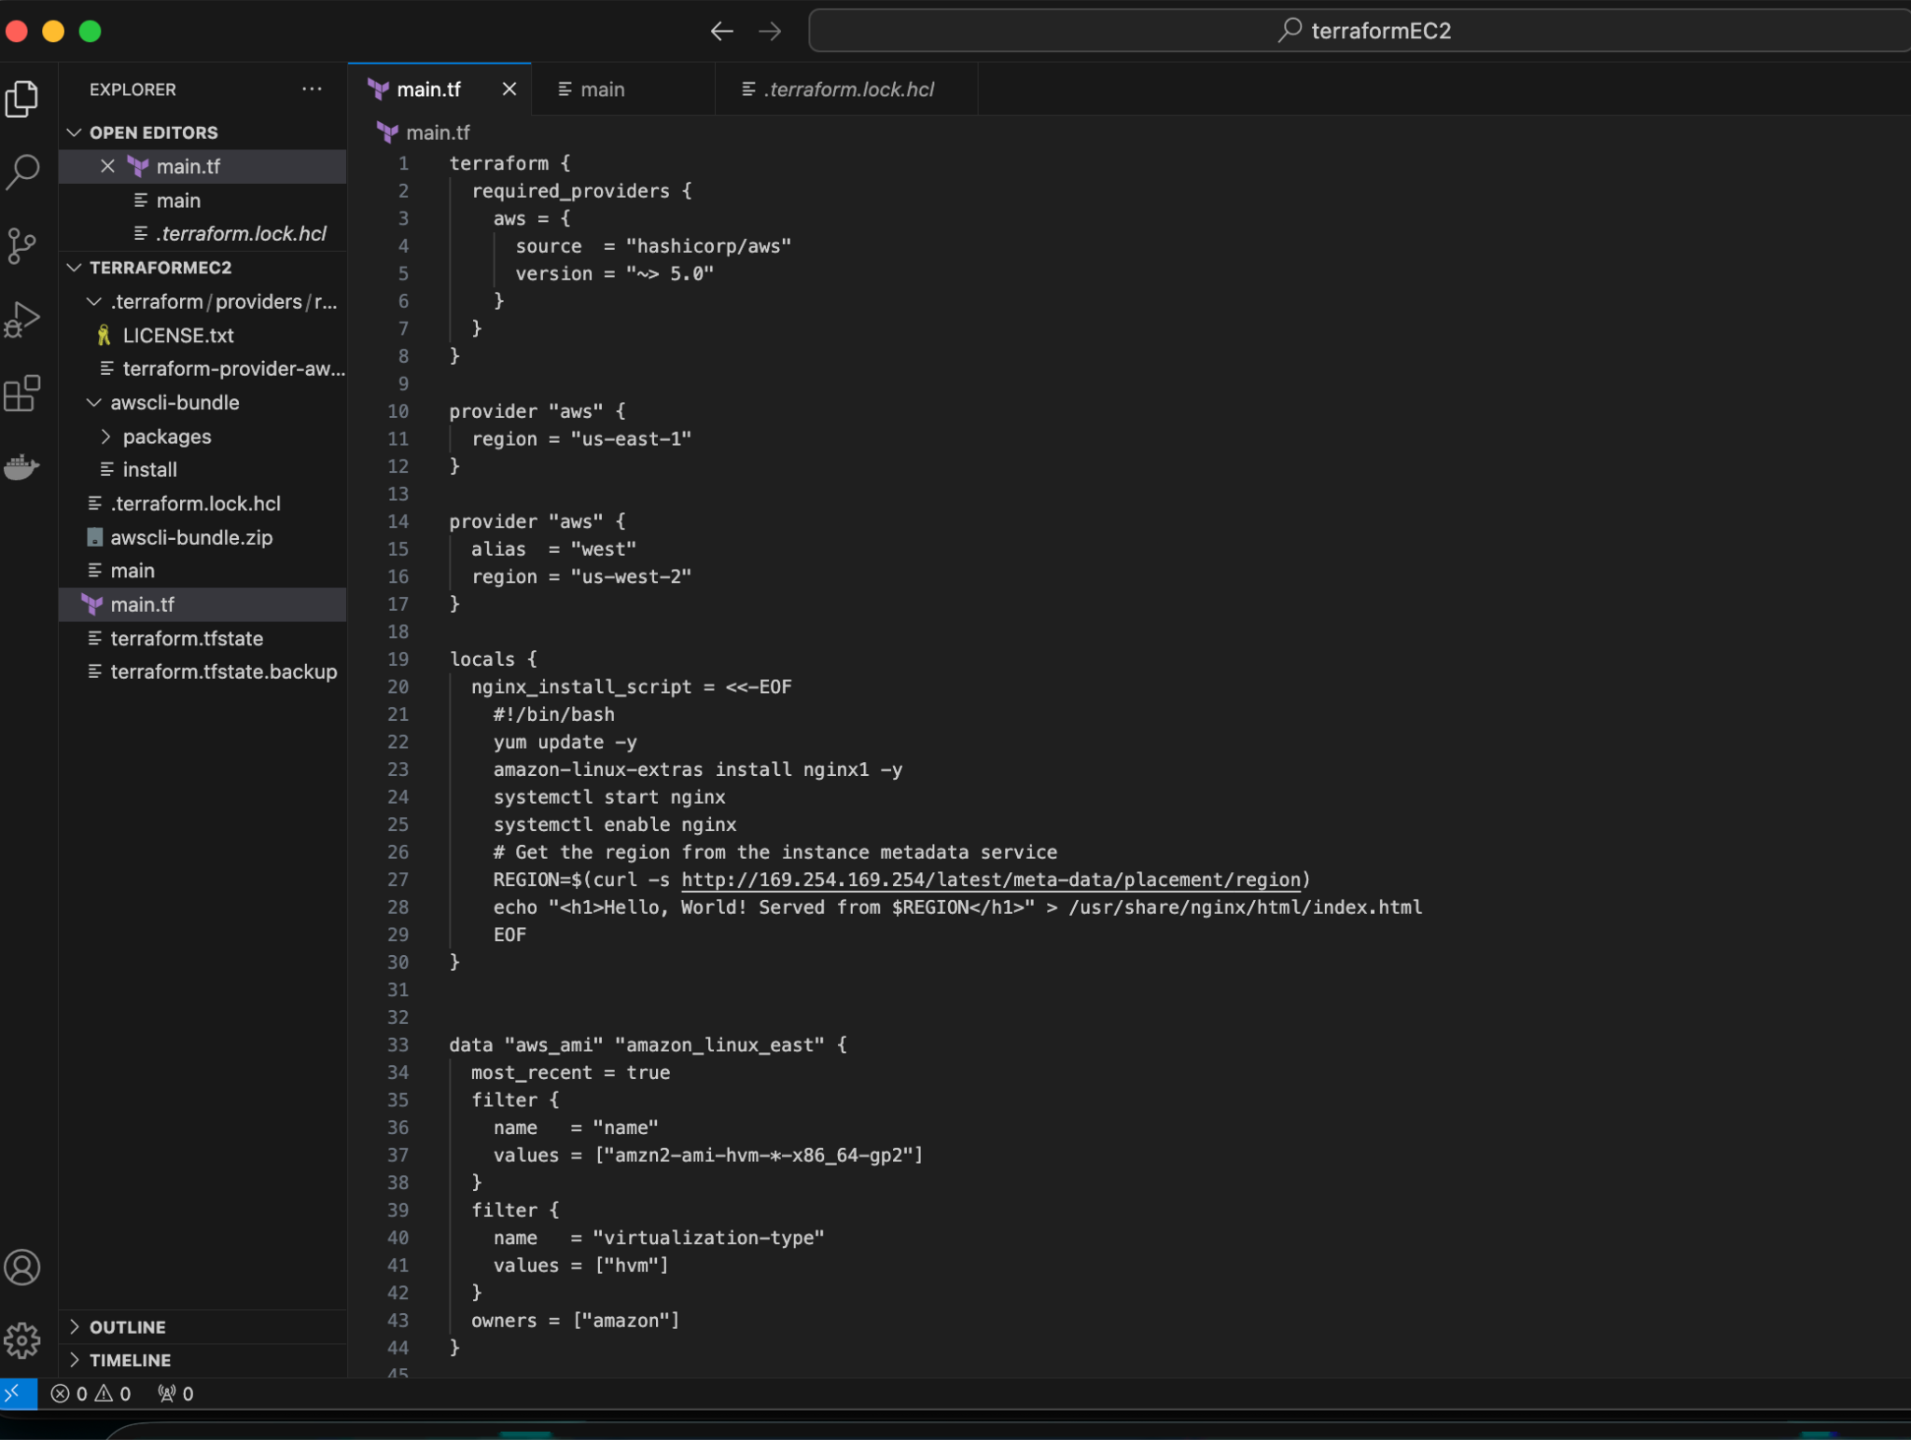

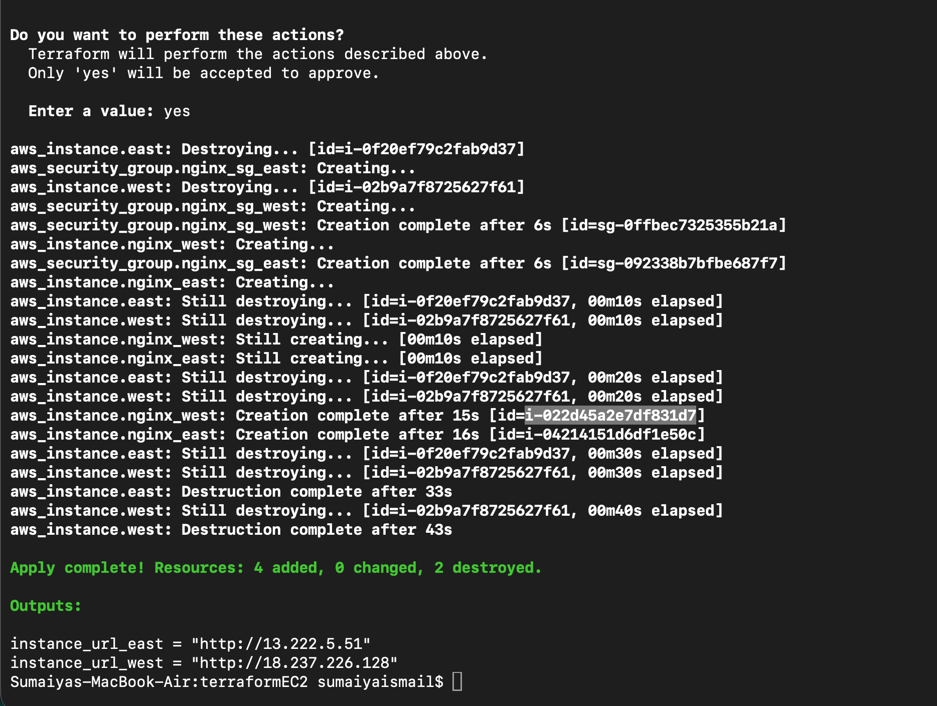

**2 ec2s created in 2 different regions**

